WeWork File Printing

Objective
- Print files at WeWork.

Required Items
- The employee must have a WeWork Community Member account.
- And the WeWork Community Member badge:
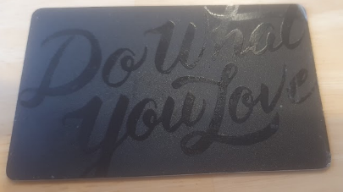

Step by Step
- The employee must access the WeWork Community Member website: WeWork
- Use the WeWork login and password to access the Community Profile.
- On the WeWork Member home page, simply 'drag' the files to the print area on the right side of the screen:
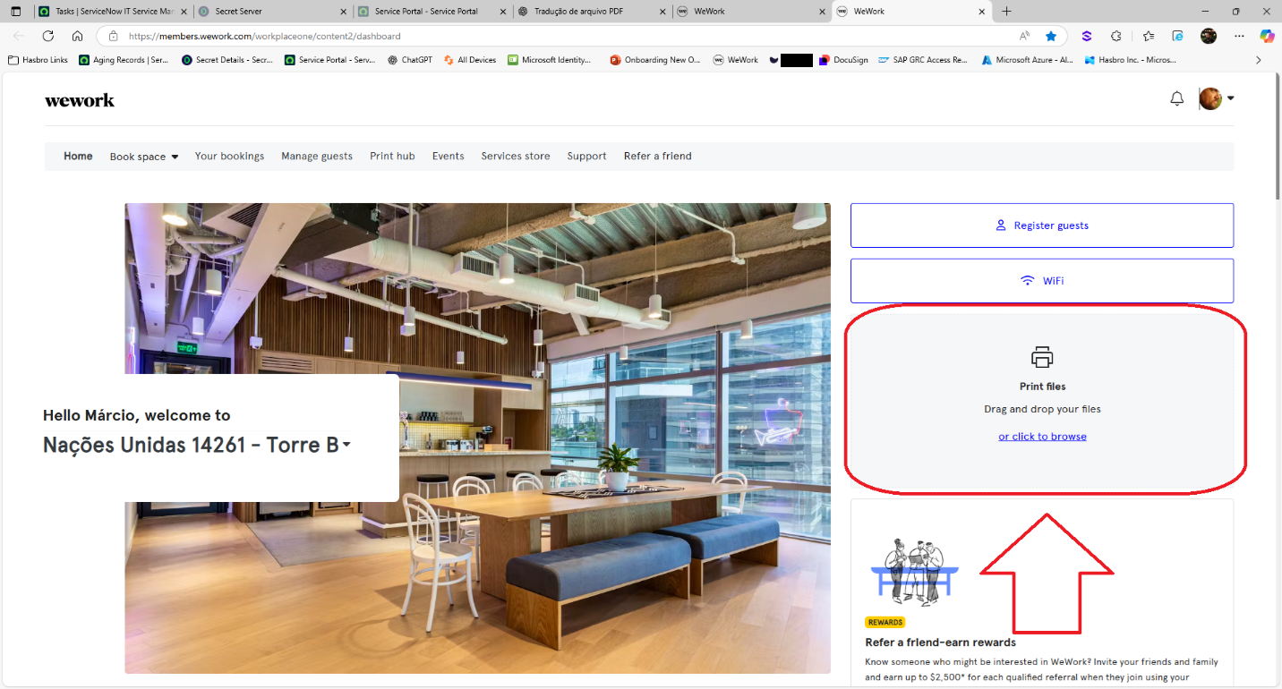
- On the following screen, confirm:
- Black & White or Color printing
- Image orientation: Portrait or Landscape; and format single-sided or double-sided.
- Number of copies.
- Add more files to the print job.
- Button to send files to the print queue.
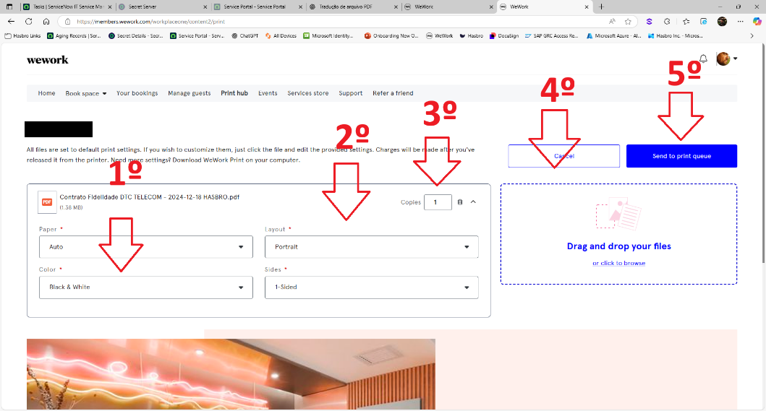
- Confirm that the print jobs were sent.
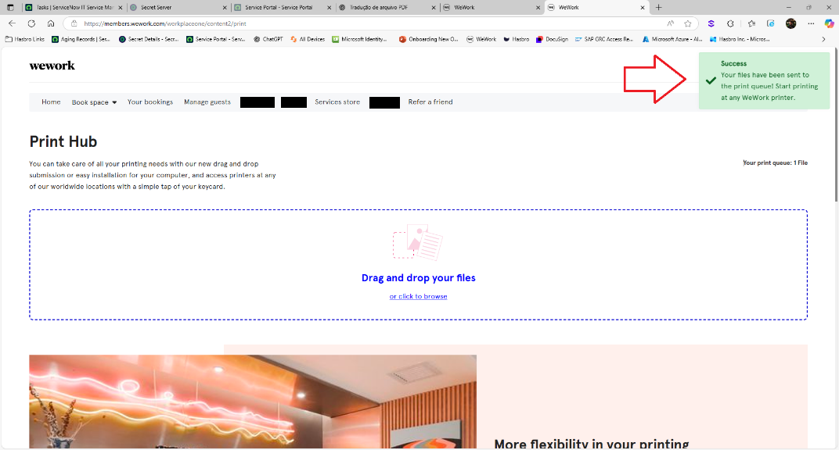
- Going to the printer (available on the 25th and 27th floors), you will need to use your WeWork Member card:
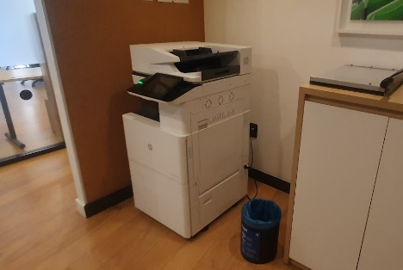
- At the printer console, use your card on the side reader:
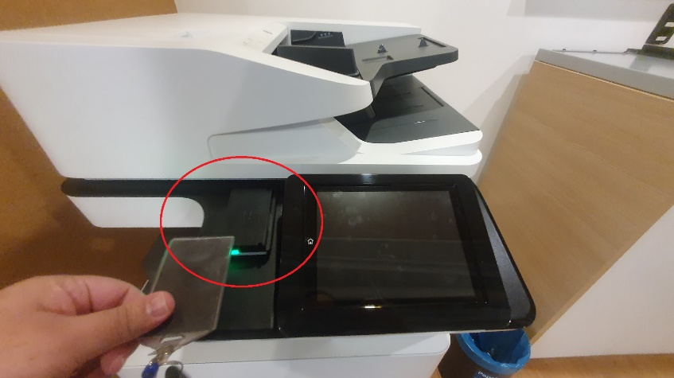
- The options screen will open:
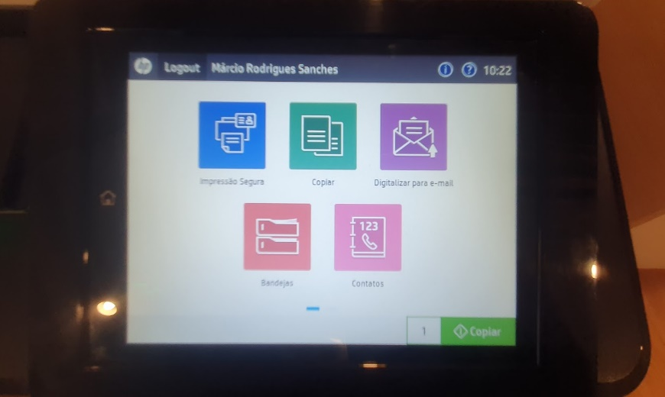
- Use the first option (in blue) to execute printing:
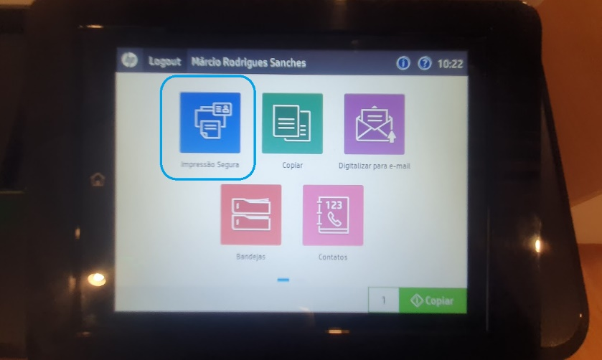
- Select the files you want to print and press the 'Print' button:
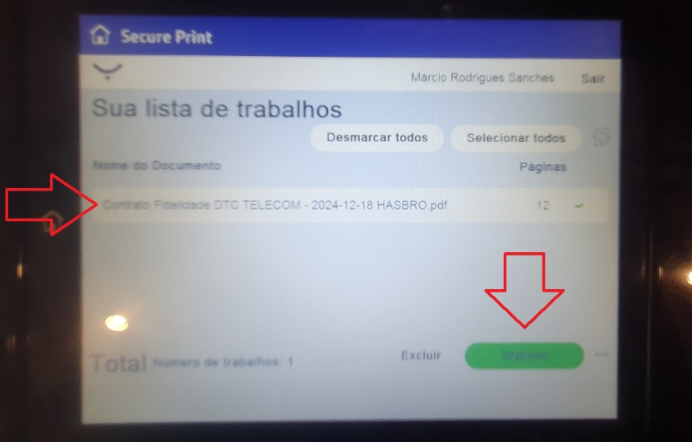
- The files will be printed in the defined order.
NOTE: Each print job uses credits that Contoso purchases monthly (250 credits).

Version History
Author | Version | Date | Description
IT Team | 1.0 | 30/07/2025 | Creation
Lucas Souza | — | Jun/2026 | Document standardization

